Serverless-Architecture-HeroVired-Assignment

HeroVired Assignment on Serverless Architecture using AWS Lambda and Boto 3

Assignment 3: Auto-Tagging EC2 Instances on Launch Using AWS Lambda and Boto3
Objective: In this assignment, we will automate the tagging of EC2 instances as soon as they are launched, ensuring better resource tracking and management.

Task: Automatically tag any newly launched EC2 instance with the current date and a custom tag

Step 1: Verify EC2 Launch Capability
- Ensure you have the capability to launch EC2 instances.
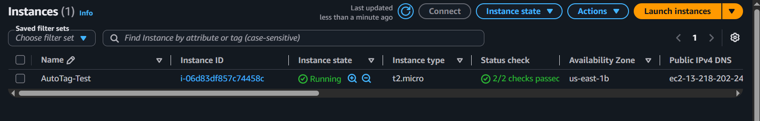

Step 2: Create IAM Role for Lambda
- In the IAM dashboard, create a new role for Lambda and attach the AmazonEC2FullAccess AWSLambdaBasicExecutionRole policy to this role.
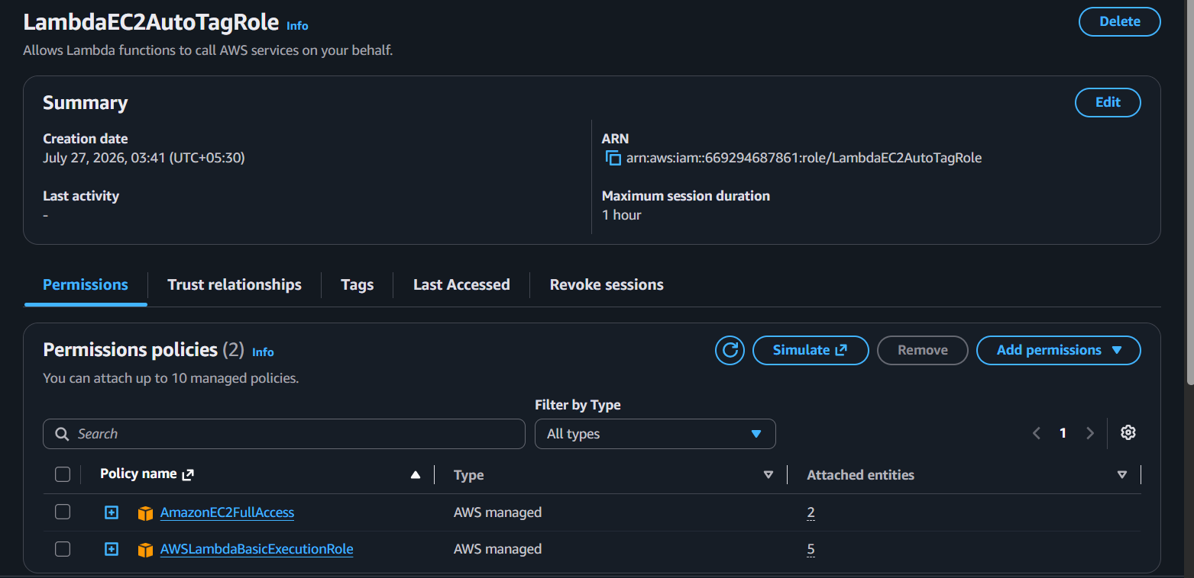

Step 3: Create Lambda Function
- Navigate to the Lambda dashboard, create a new function by choosing Python 3.14 as the runtime and assign the custom role created in the previous step.
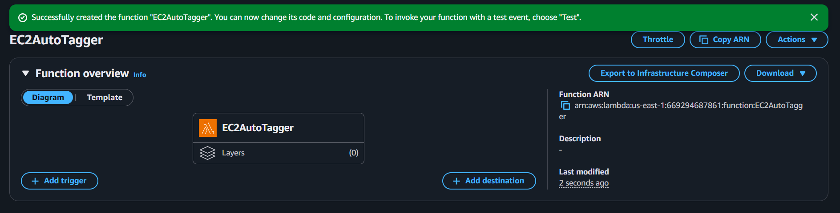

2.Write the Boto3 Python script to:
  - Initialize a boto3 EC2 client.
  - Retrieve the instance ID from the event.
  - Tag the new instance with the current date and another tag of your choice.
  - Print a confirmation message for logging purposes.
import boto3
from datetime import datetime

ec2 = boto3.client('ec2')

def lambda_handler(event, context):

instance_id = event['detail']['instance-id']

current_date = datetime.utcnow().strftime(
'%Y-%m-%d'
)

ec2.create_tags(
Resources=[instance_id],
Tags=[
{
'Key': 'LaunchDate',
'Value': current_date
},
{
'Key': 'Environment',
'Value': 'Development'
}
]
)

print(
f"Tagged instance {instance_id}"
)

return {
'statusCode': 200,
'instance_id': instance_id
}

Step 4: CloudWatch Events
- Set up a CloudWatch Event Rule to trigger the EC2 instance launch event.
  - Open: Amazon EventBridge
  - Create Rule user rule name: EC2AutoTagRule
  - Event bus: Default
  - Rule Type: Rule with Event Pattern
  - Event Source: AWS Events
  - Service Name: EC2
  - Event type: EC2 Instance State-change Notification and state running

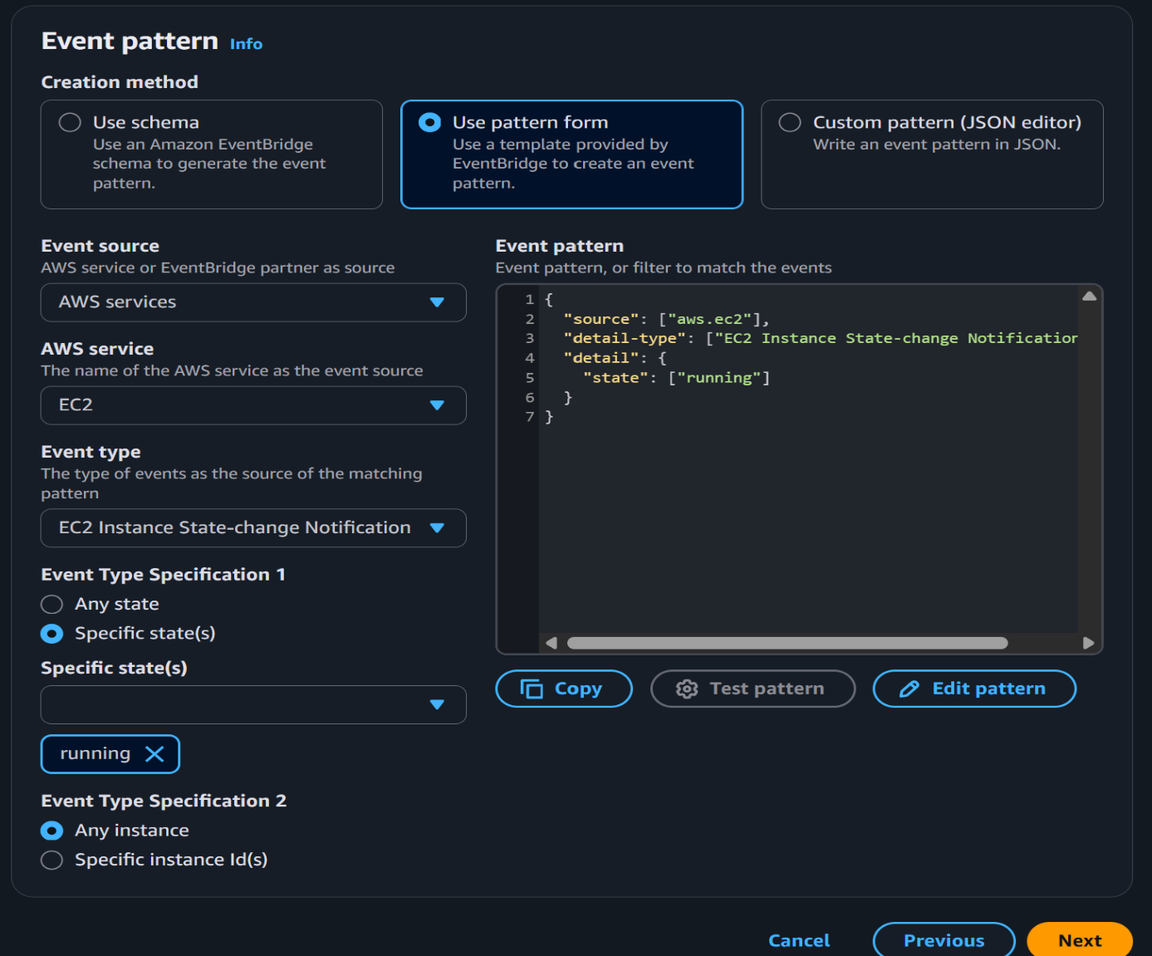

2.Attach the Lambda function as the target.
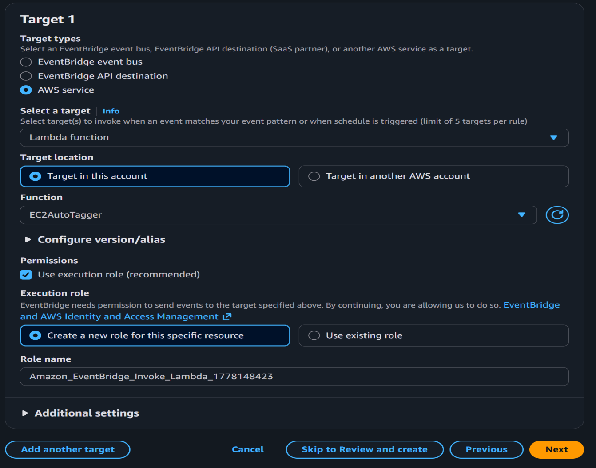
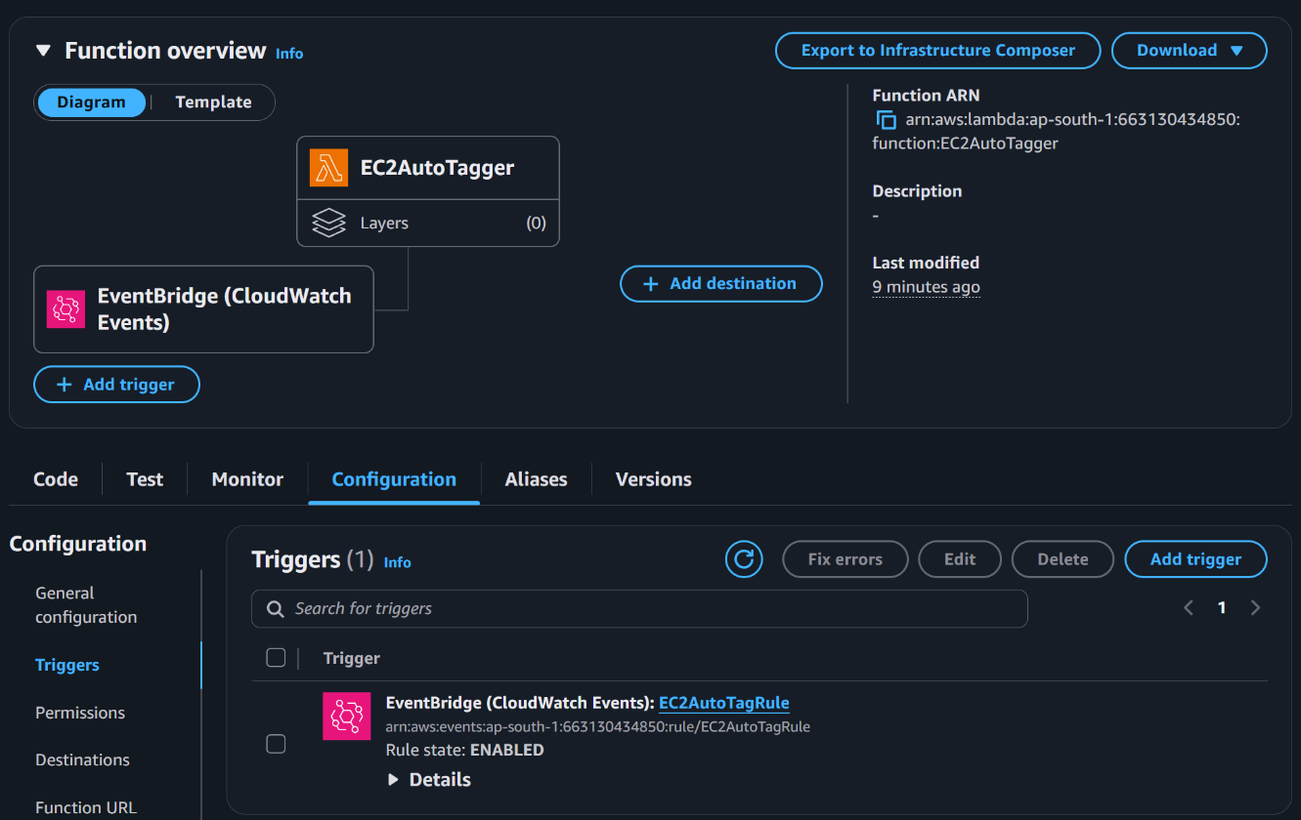

Step 4: Testing
- Launch a new EC2 instance.

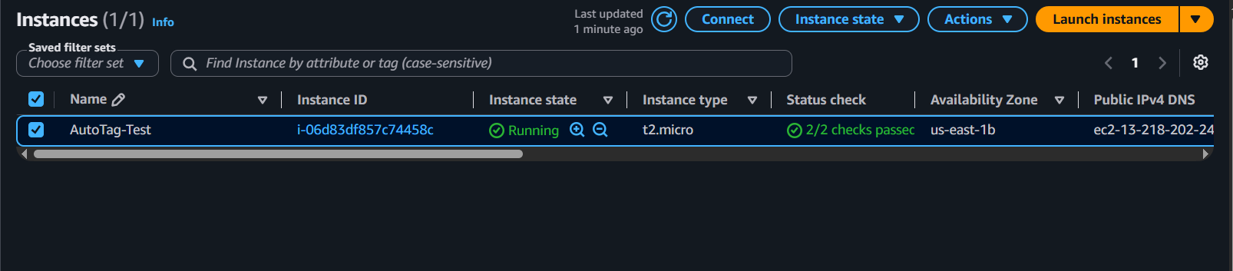

2.After a short delay, confirm that the instance is automatically tagged as specified
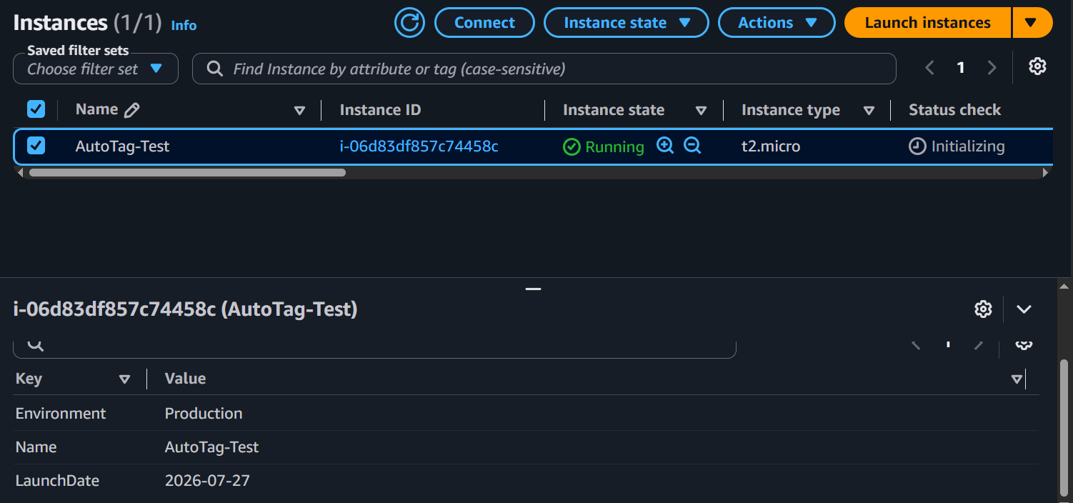
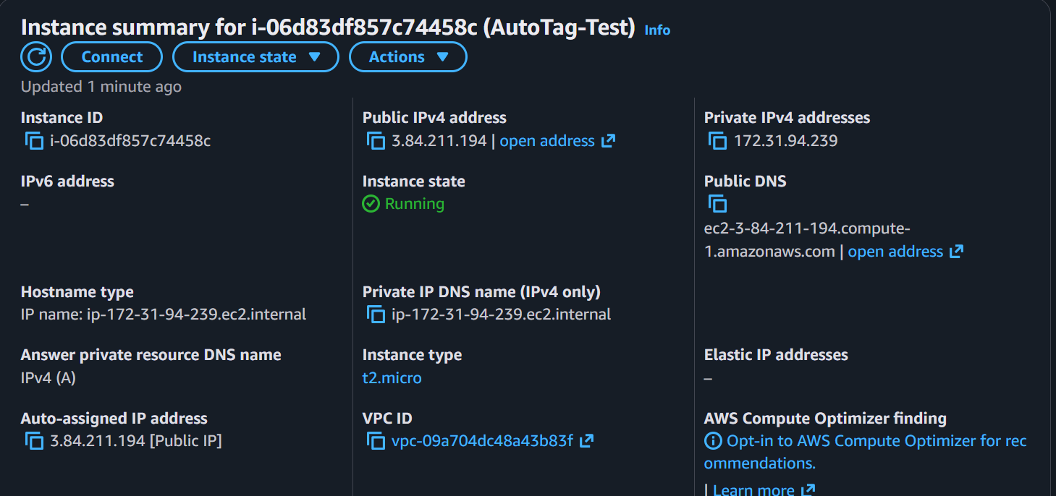

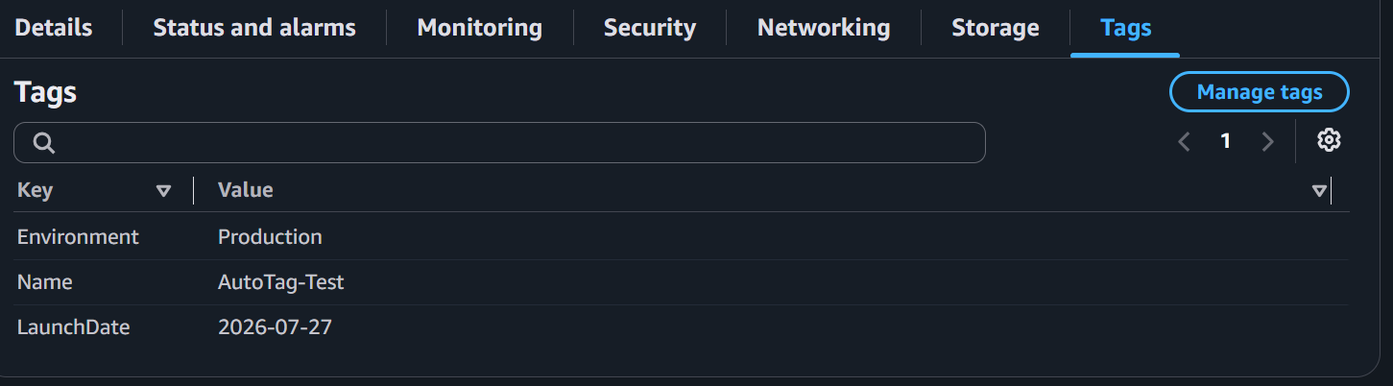

Step 5: Verify CloudWatch Logs
- Open Lambda → Monitor
- Click View CloudWatch Logs
- Check the logs for tagged instance i-06d83df857c74458c
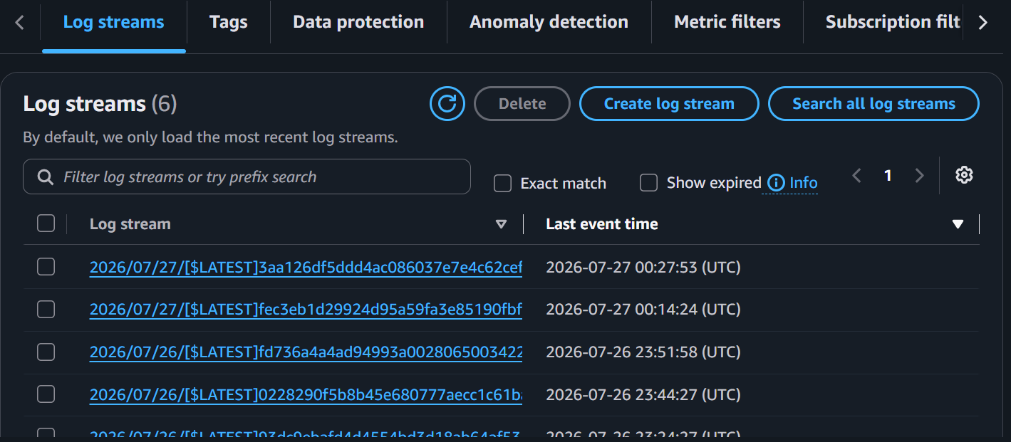
4.We can also test it manually changing JSON in the Lambda function.
{
"detail": {
"instance-id": "i-093ebfa1bd4d101f1",
"state": "running"
}
}

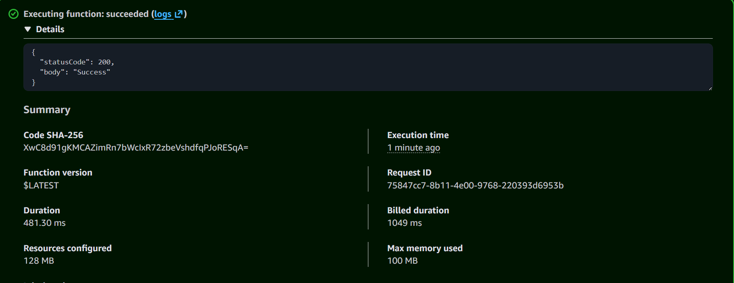
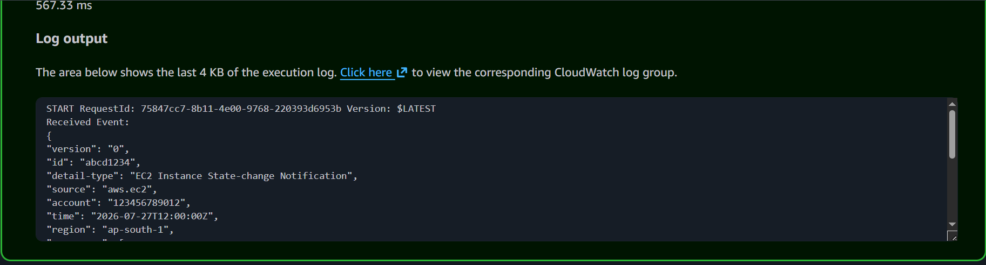

Architecture Overview:
